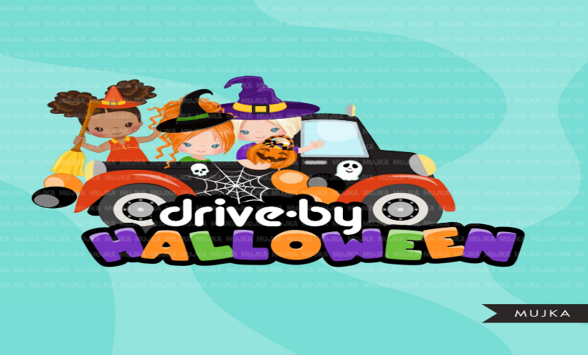
PTA presents Grimmer’s
1st Halloween Drive-Thru Parade

Wednesday, October 28th 5-7pm
Bring the whole family wearing costumes and face coverings
for a fun Halloween experience in YOUR OWN CAR!
You will get to wave to Mrs. Nye, Grimmer teachers, and PTA Board members
while picking up
Halloween treats for the kiddos.

Tips:
-wear costumes, face masks
-decorate your car
-honk your horn
-ensure all family members remain in the car with seatbelts on

RSVP to LaTisha, PTA President, with how many kiddos you’re bringing:
650.296.2609

